**die lateinischen Buchstaben, die Handschrift**

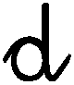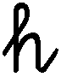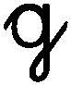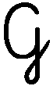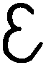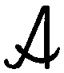

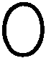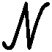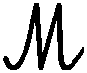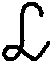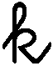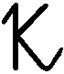

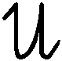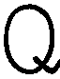

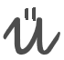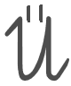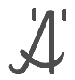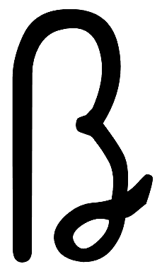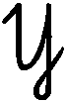

**1 2 3 4 5 6 7 8 9 10**

**Buchstaben, Übungszeilen**

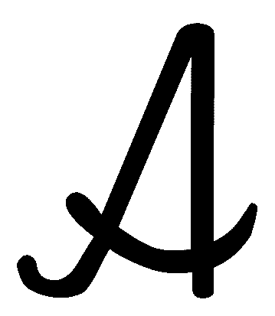 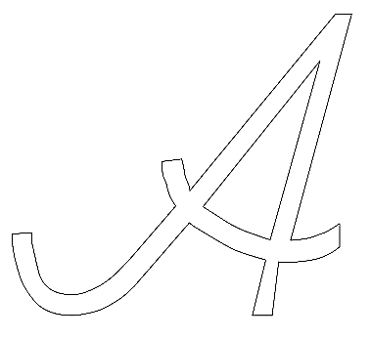    

|  |  |
| --- | --- |
|  |  |
|  |
|  |  |

 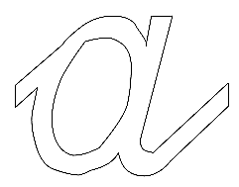    

|  |  |
| --- | --- |
|  |  |
|  |  |
|  |  |

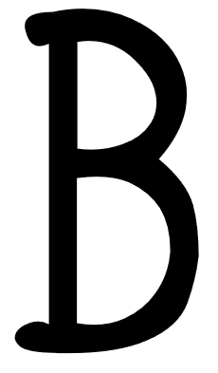 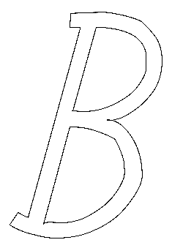    

|  |  |
| --- | --- |
|  |  |
|  |
|  |  |

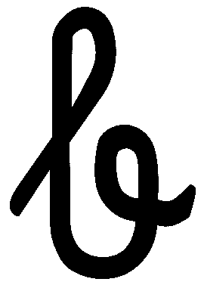 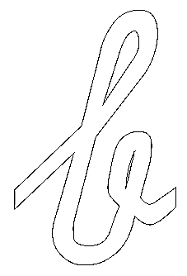    

|  |  |
| --- | --- |
|  |  |
|  |
|  |  |

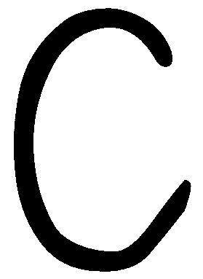 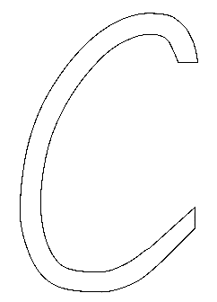    

|  |  |
| --- | --- |
|  |  |
|  |
|  |  |

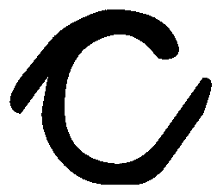 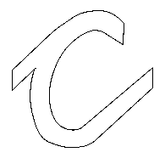    

|  |  |
| --- | --- |
|  |  |
|  |
|  |  |

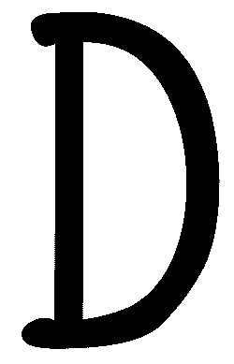 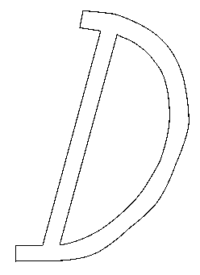    

|  |  |
| --- | --- |
|  |  |
|  |
|  |  |

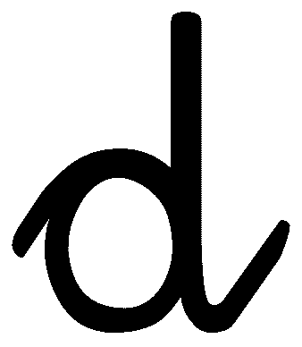 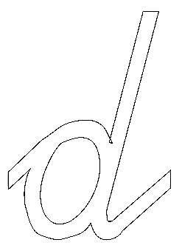    

|  |  |
| --- | --- |
|  |  |
|  |
|  |  |

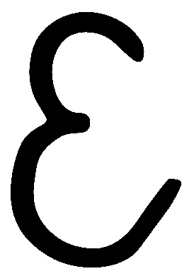 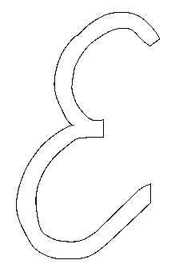    

|  |  |
| --- | --- |
|  |  |
|  |
|  |  |

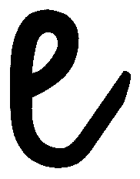 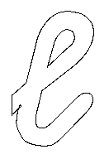    

|  |  |
| --- | --- |
|  |  |
|  |
|  |  |

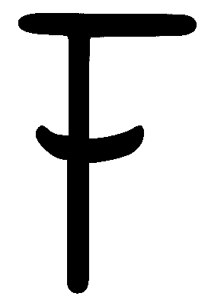 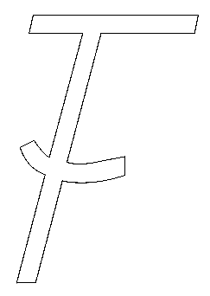    

|  |  |
| --- | --- |
|  |  |
|  |
|  |  |

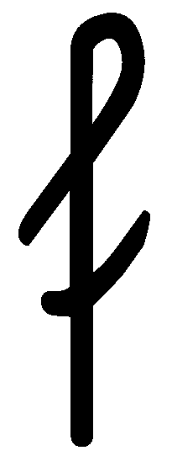 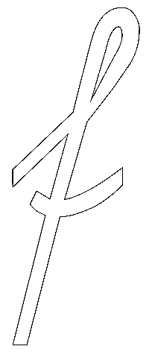    

|  |  |
| --- | --- |
|  |  |
|  |
|  |

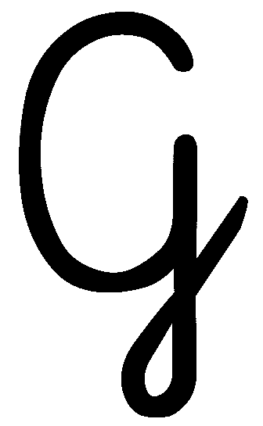 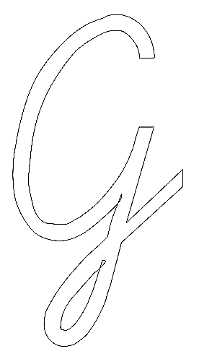    

|  |  |
| --- | --- |
|  |  |
|  |
|  |

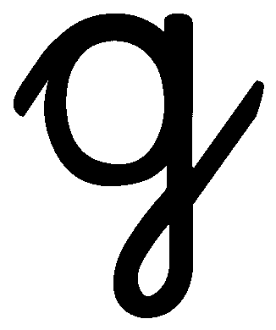 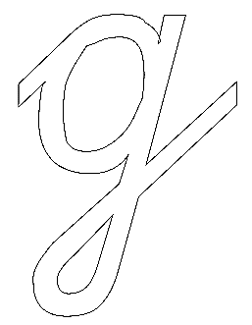    

|  |  |
| --- | --- |
|  |  |
|  |  |
|  |

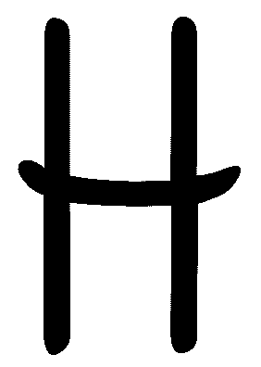 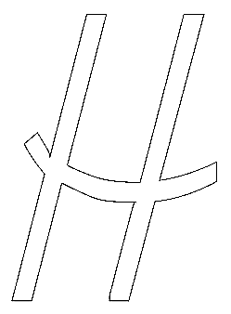    

|  |  |
| --- | --- |
|  |  |
|  |
|  |  |

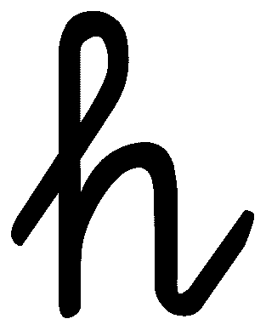 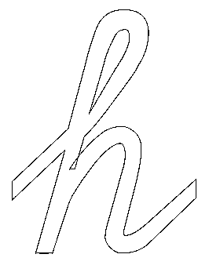    

|  |  |
| --- | --- |
|  |  |
|  |
|  |  |

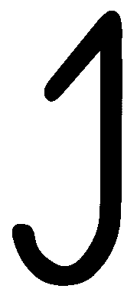 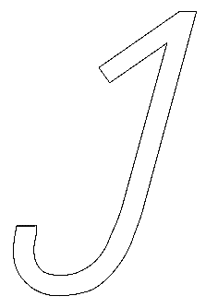    

|  |  |
| --- | --- |
|  |  |
|  |
|  |  |

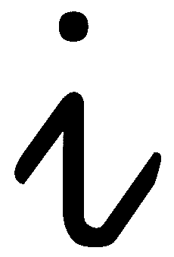 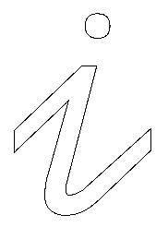    

|  |  |
| --- | --- |
|  |  |
|  |
|  |  |

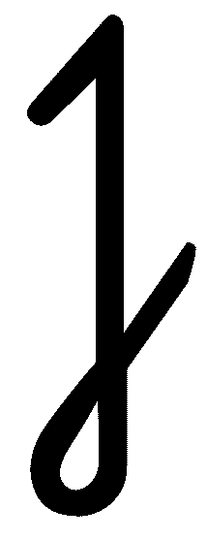 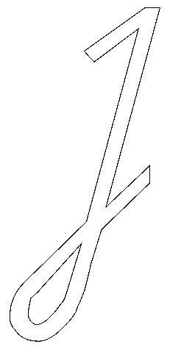    

|  |  |
| --- | --- |
|  |  |
|  |
|  |

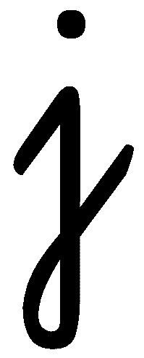 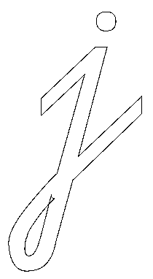    

|  |  |
| --- | --- |
|  |  |
|  |  |
|  |

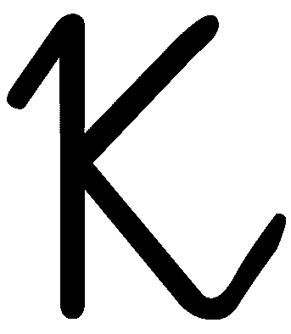 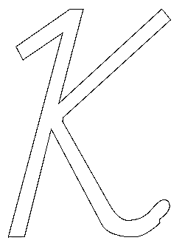    

|  |  |
| --- | --- |
|  |  |
|  |
|  |

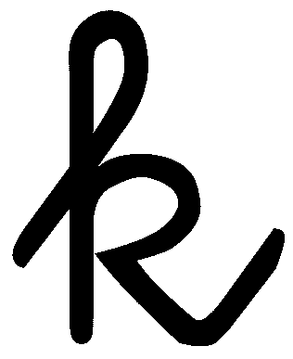 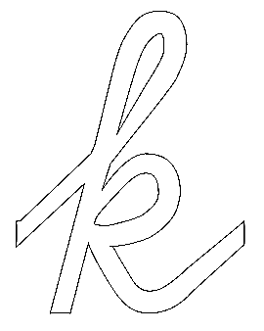    

|  |  |
| --- | --- |
|  |  |
|  |
|  |  |

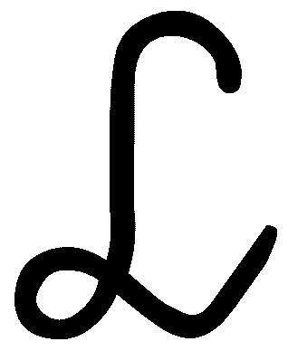 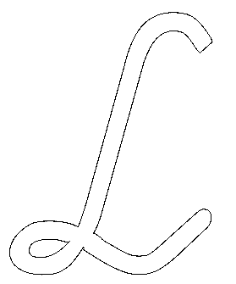    

|  |  |
| --- | --- |
|  |  |
|  |
|  |

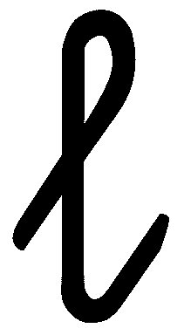 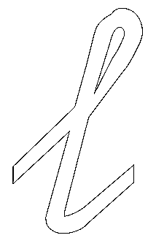    

|  |  |
| --- | --- |
|  |  |
|  |
|  |  |

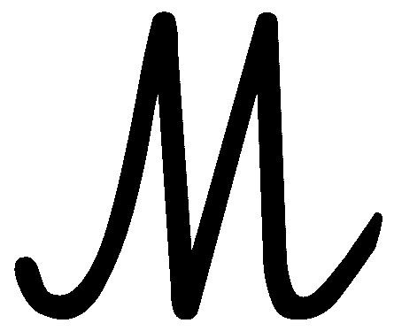 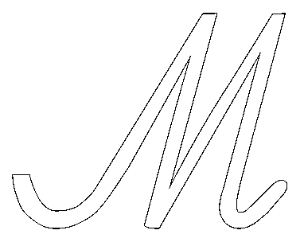    

|  |  |
| --- | --- |
|  |  |
|  |
|  |

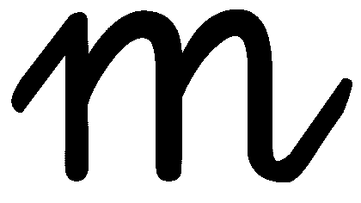 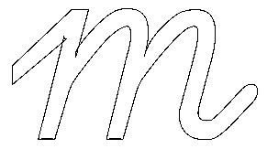    

|  |  |
| --- | --- |
|  |  |
|  |
|  |  |

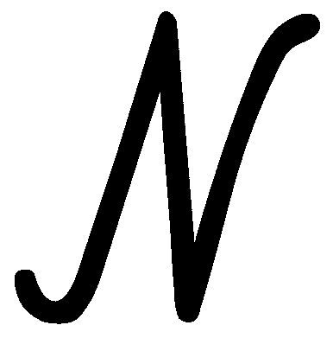 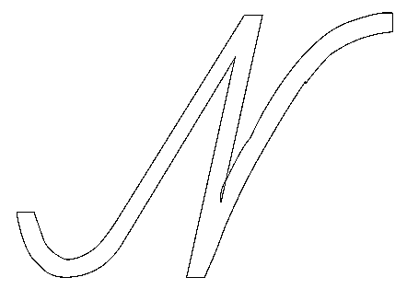    

|  |  |
| --- | --- |
|  |  |
|  |
|  |  |

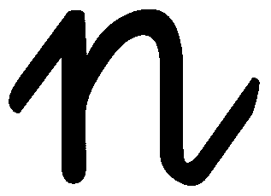 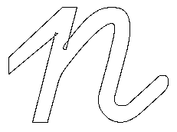    

|  |  |
| --- | --- |
|  |  |
|  |
|  |  |

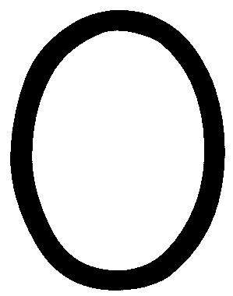 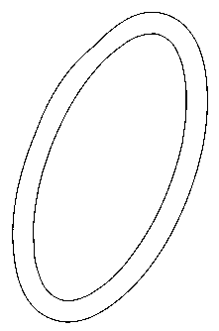    

|  |  |
| --- | --- |
|  |  |
|  |
|  |  |

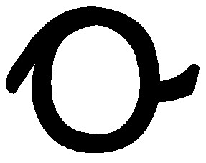 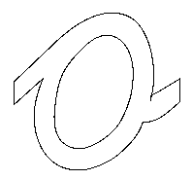    

|  |  |
| --- | --- |
|  |  |
|  |
|  |  |

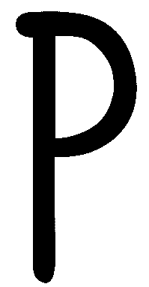 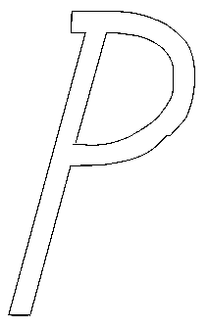    

|  |  |
| --- | --- |
|  |  |
|  |
|  |  |

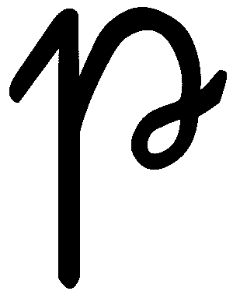 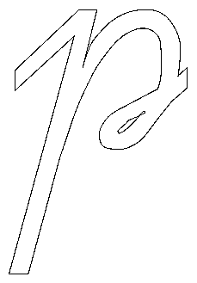    

|  |  |
| --- | --- |
|  |  |
|  |  |
|  |

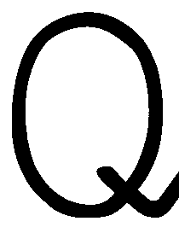 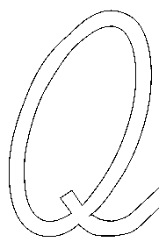    

|  |  |
| --- | --- |
|  |  |
|  |
|  |  |

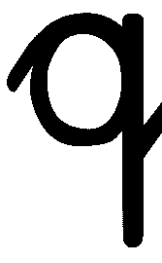 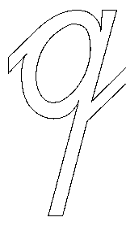    

|  |  |
| --- | --- |
|  |  |
|  |  |
|  |

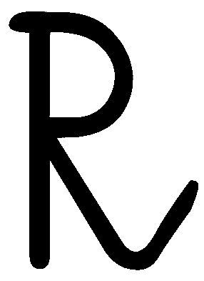 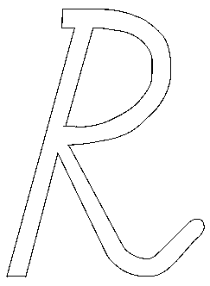    

|  |  |
| --- | --- |
|  |  |
|  |
|  |  |

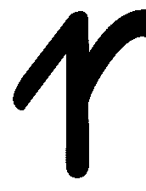 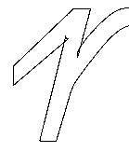    

|  |  |
| --- | --- |
|  |  |
|  |
|  |  |

 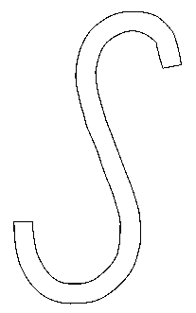    

|  |  |
| --- | --- |
|  |  |
|  |
|  |  |

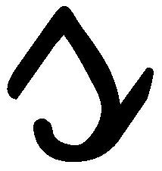 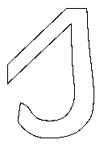    

|  |  |
| --- | --- |
|  |  |
|  |
|  |  |

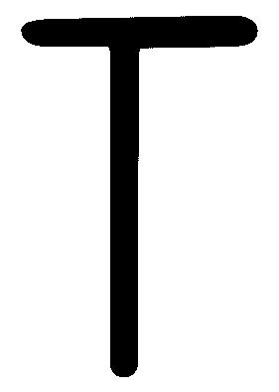 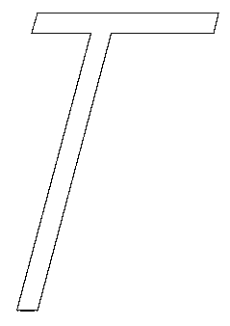    

|  |  |
| --- | --- |
|  |  |
|  |
|  |  |

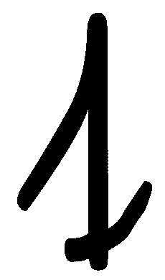 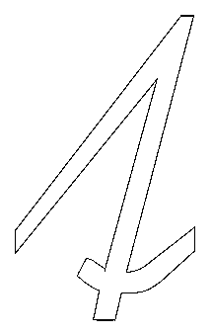    

|  |  |
| --- | --- |
|  |  |
|  |
|  |  |

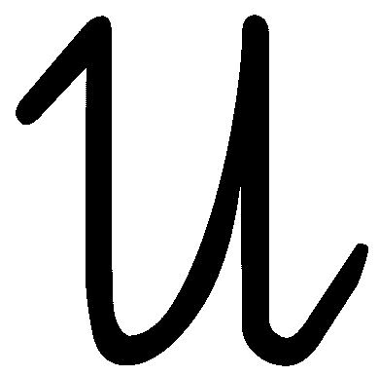 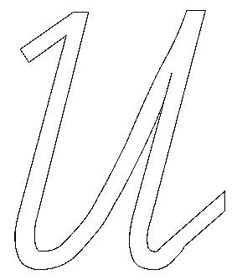    

|  |  |
| --- | --- |
|  |  |
|  |
|  |  |

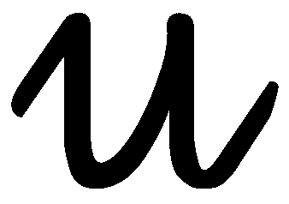 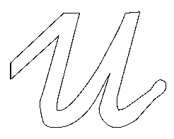    

|  |  |
| --- | --- |
|  |  |
|  |
|  |  |

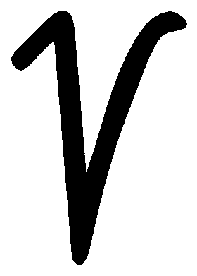 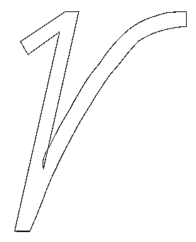    

|  |  |
| --- | --- |
|  |  |
|  |
|  |  |

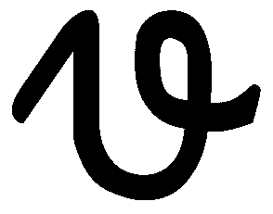 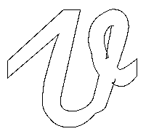    

|  |  |
| --- | --- |
|  |  |
|  |
|  |  |

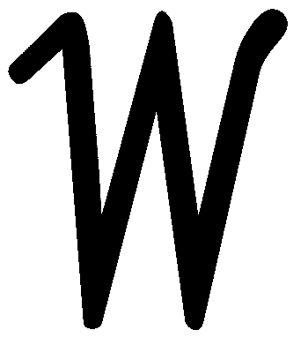 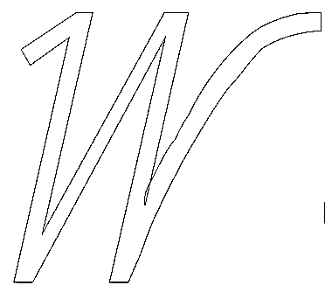    

|  |  |
| --- | --- |
|  |  |
|  |
|  |  |

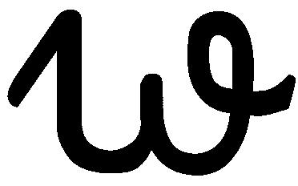 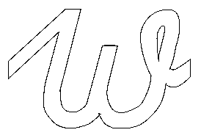    

|  |  |
| --- | --- |
|  |  |
|  |
|  |  |

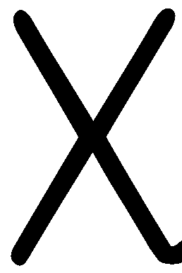 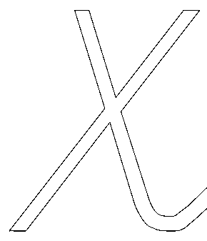    

|  |  |
| --- | --- |
|  |  |
|  |
|  |  |

 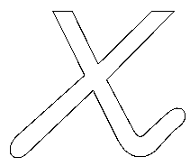    

|  |  |
| --- | --- |
|  |  |
|  |
|  |  |

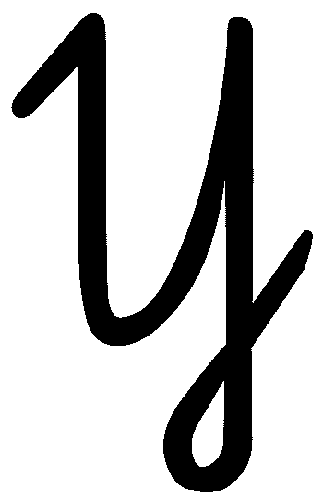 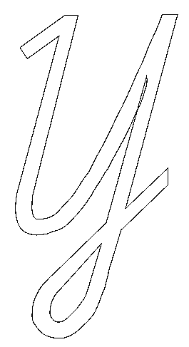    

|  |  |
| --- | --- |
|  |  |
|  |
|  |

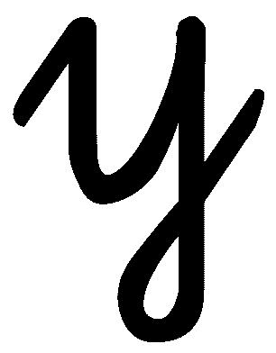 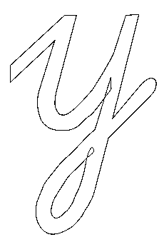    

|  |  |
| --- | --- |
|  |  |
|  |  |
|  |

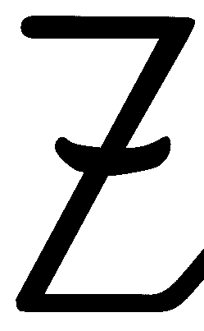 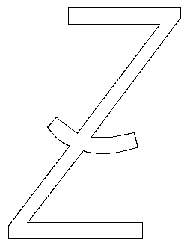    

|  |  |
| --- | --- |
|  |  |
|  |
|  |  |

 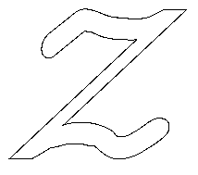    

|  |  |
| --- | --- |
|  |  |
|  |  |
|  |  |

**das „scharfe s“**

 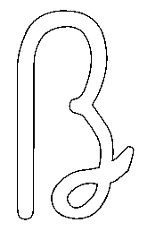    

|  |  |
| --- | --- |
|  |  |
|  |
|  |  |

**die Umlaute** – **ä** … Umlaut a / **ö** … Umlaut o / **ü** … Umlaut u

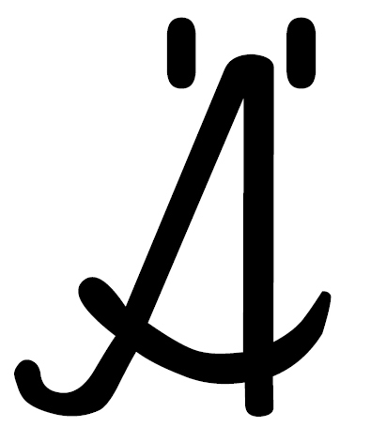 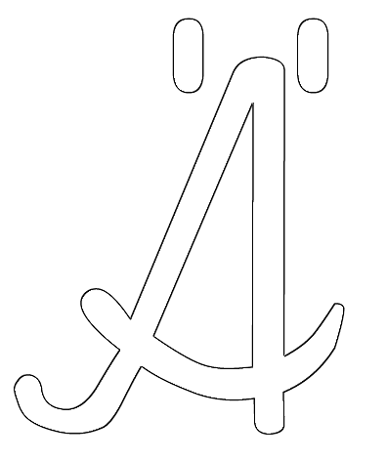    

|  |  |
| --- | --- |
|  |  |
|  |
|  |  |

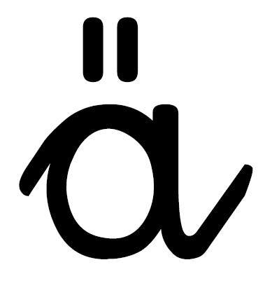 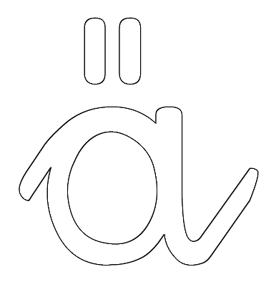    

|  |  |
| --- | --- |
|  |  |
|  |
|  |  |

 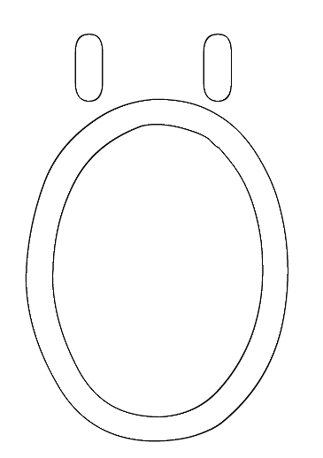    

|  |  |
| --- | --- |
|  |  |
|  |
|  |  |

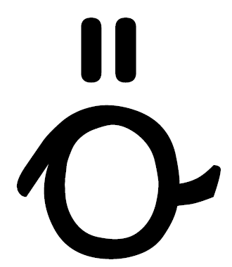 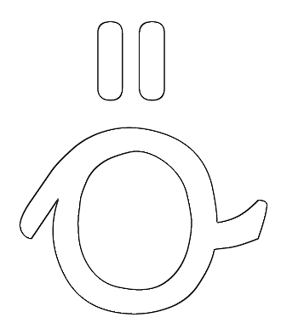    

|  |  |
| --- | --- |
|  |  |
|  |
|  |  |

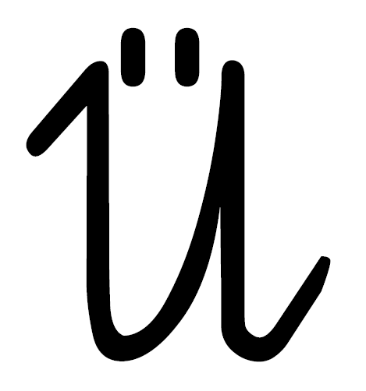 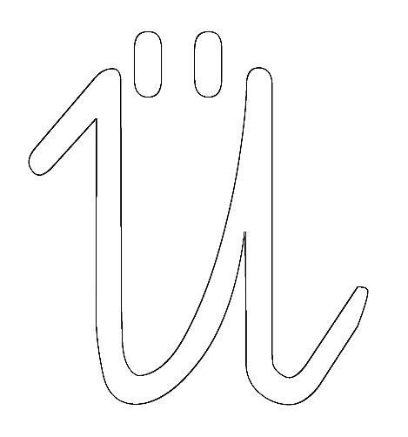    

|  |  |
| --- | --- |
|  |  |
|  |
|  |  |

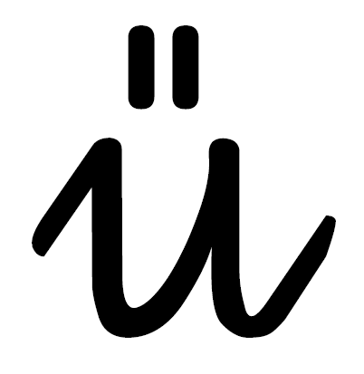 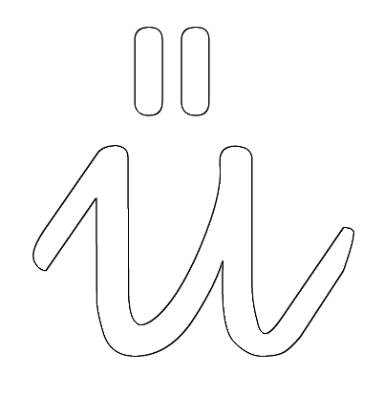    

|  |  |
| --- | --- |
|  |  |
|  |
|  |  |

**die Ziffern – die Zahl**

null – die Null

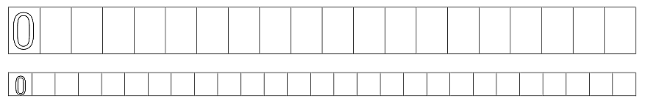

eins – der Einser

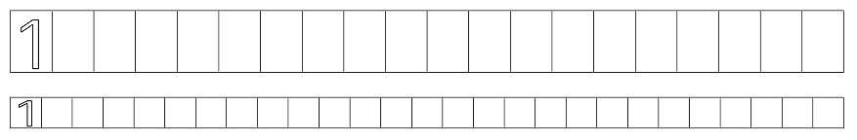

zwei – der Zweier

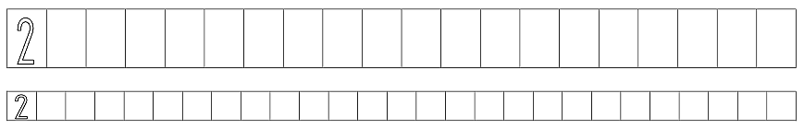

drei – der Dreier

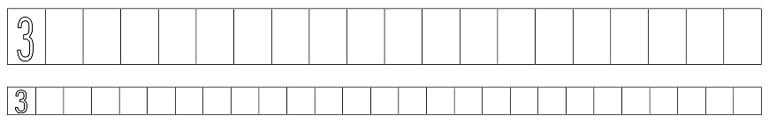

vier – der Vierer

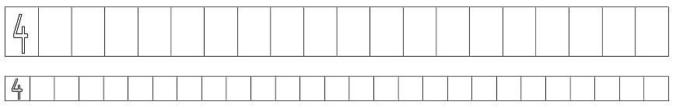

fünf – der Fünfer

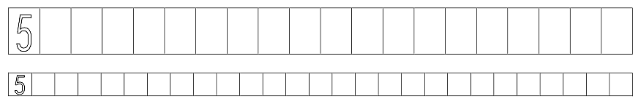

sechs – der Sechser

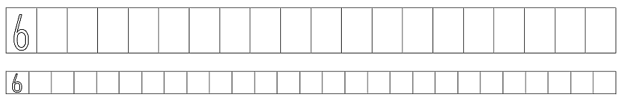

sieben – der Siebener

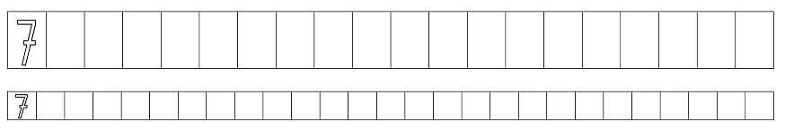

acht – der Achter

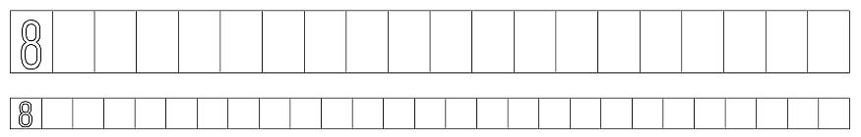

neun – der Neuner

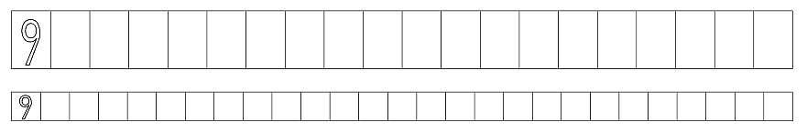

zehn – der Zehner

